5907101009 นาย ชุติโชค พิทยจำรัส

5907101011 นาย สิรวิชญ์ เตชะวณิชย์

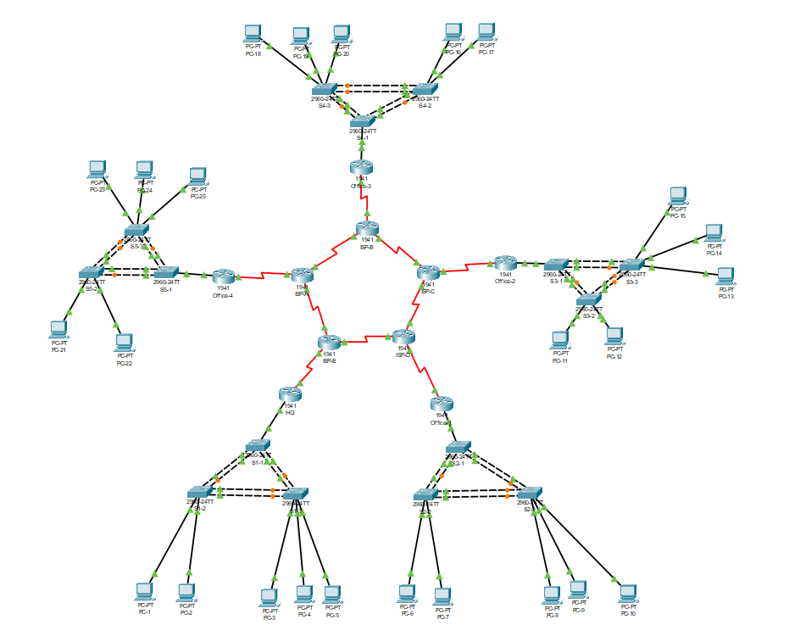

|  |  |  |  |
| --- | --- | --- | --- |
|  | interface | IP | Subnet mask |
| ISP-A | s0/0/0 | 172.10.10.21 | 255.255.255.252 |
|  | s0/0/1 | 172.10.10.5 | 255.255.255.252 |
|  | s0/1/0 | 172.10.11.73 | 255.255.255.252 |
| Office-4 | s0/1/0 | 172.10.11.74 | 255.255.255.252 |
|  | g0/0.10 | 172.16.10.1 | 255.255.255.0 |
|  | g0/0.20 | 172.16.20.1 | 255.255.255.0 |
|  | g0/0.30 | 172.16.30.1 | 255.255.255.128 |
|  | g0/0.40 | 172.16.40.1 | 255.255.255.128 |
|  | g0/0.50 | 172.16.50.1 | 255.255.255.128 |
|  | Tunnel3 | 172.16.15.2 | 255.255.255.252 |

*LAN 2 วง วงละ 200 เครื่อง , LAN 3 วง วงละ 100 เครื่อง

|  |  |  |  |
| --- | --- | --- | --- |
|  | interface | IP | Subnet mask |
| ISP-B | s0/0/0 | 172.10.10.9 | 255.255.255.252 |
|  | s0/0/1 | 172.10.10.6 | 255.255.255.252 |
|  | s0/1/0 | 172.10.11.61 | 255.255.255.252 |
| Office-3 | s0/1/0 | 172.10.11.62 | 255.255.255.252 |
|  | g0/0.10 | 172.16.10.1 | 255.255.254.0 |
|  | g0/0.20 | 172.16.20.1 | 255.255.254.0 |
|  | g0/0.30 | 172.16.30.1 | 255.255.255.192 |
|  | g0/0.40 | 172.16.40.1 | 255.255.255.192 |
|  | g0/0.50 | 172.16.50.1 | 255.255.255.192 |
|  | Tunnel2 | 172.16.14.2 | 255.255.255.252 |

*LAN 2 วง วงละ 500 เครื่อง , LAN 3 วง วงละ 60 เครื่อง

|  |  |  |  |
| --- | --- | --- | --- |
|  | interface | IP | Subnet mask |
| ISP-C | s0/0/0 | 172.10.10.10 | 255.255.255.252 |
|  | s0/0/1 | 172.10.10.13 | 255.255.255.252 |
|  | s0/1/0 | 172.10.11.25 | 255.255.255.252 |
| Office-2 | s0/1/0 | 172.10.11.26 | 255.255.255.252 |
|  | g0/0.10 | 172.16.10.1 | 255.255.255.0 |
|  | g0/0.20 | 172.16.20.1 | 255.255.255.0 |
|  | g0/0.30 | 172.16.30.1 | 255.255.255.224 |
|  | g0/0.40 | 172.16.40.1 | 255.255.255.224 |
|  | g0/0.50 | 172.16.50.1 | 255.255.255.224 |
|  | Tunnel1 | 172.16.13.2 | 255.255.255.252 |
|  | Tunnel0 | 172.16.12.2 | 255.255.255.252 |

*LAN 2 วง วงละ 200 เครื่อง, LAN 3 วง วงละ 30 เครื่อง

|  |  |  |  |
| --- | --- | --- | --- |
|  | interface | IP | Subnet mask |
| ISP-D | s0/0/0 | 172.10.10.17 | 255.255.255.252 |
|  | s0/0/1 | 172.10.10.14 | 255.255.255.252 |
|  | s0/1/0 | 172.10.11.21 | 255.255.255.252 |
| Office-1 | s0/1/0 | 172.10.11.22 | 255.255.255.252 |
|  | g0/0.10 | 172.16.10.1 | 255.255.255.128 |
|  | g0/0.20 | 172.16.20.1 | 255.255.255.128 |
|  | g0/0.30 | 172.16.30.1 | 255.255.255.192 |
|  | g0/0.40 | 172.16.40.1 | 255.255.255.192 |
|  | g0/0.50 | 172.16.50.1 | 255.255.255.192 |
|  | Tunnel0 | 172.16.12.2 | 255.255.255.252 |

*LAN 2 วง วงละ 80 เครื่อง , LAN 3 วง วงละ 60 เครื่อง

|  |  |  |  |
| --- | --- | --- | --- |
|  | interface | IP | Subnet mask |
| ISP-E | s0/0/0 | 172.10.10.22 | 255.255.255.252 |
|  | s0/0/1 | 172.10.10.18 | 255.255.255.252 |
|  | s0/1/0 | 172.10.11.17 | 255.255.255.252 |
| HQ | s0/1/0 | 172.10.11.18 | 255.255.255.252 |
|  | g0/0.10 | 172.16.10.1 | 255.255.254.0 |
|  | g0/0.20 | 172.16.20.1 | 255.255.254.0 |
|  | g0/0.30 | 172.16.30.1 | 255.255.255.128 |
|  | g0/0.40 | 172.16.40.1 | 255.255.255.128 |
|  | g0/0.50 | 172.16.50.1 | 255.255.255.128 |
|  | Tunnel0 | 172.16.12.1 | 255.255.255.252 |
|  | Tunnel1 | 172.16.13.1 | 255.255.255.252 |
|  | Tunnel2 | 172.16.14.1 | 255.255.255.252 |
|  | Tunnel3 | 172.16.15.1 | 255.255.255.252 |

*LAN 2 วง วงละ 500 เครื่อง , LAN 3 วง วงละ 100 เครื่อง